**Collections Framework**

A Collection is a group of objects.

Collections framework provides a set of standard utility classes to manage collections.

Collections Framework consists of three parts:

* + Core Interfaces
  + Concrete Implementation
  + Algorithms such as searching and sorting

Collection Framework is a part of **java.util package.**

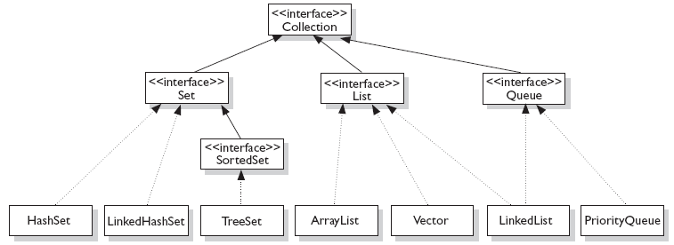

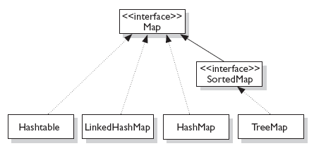

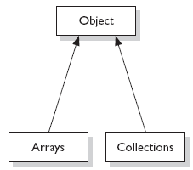

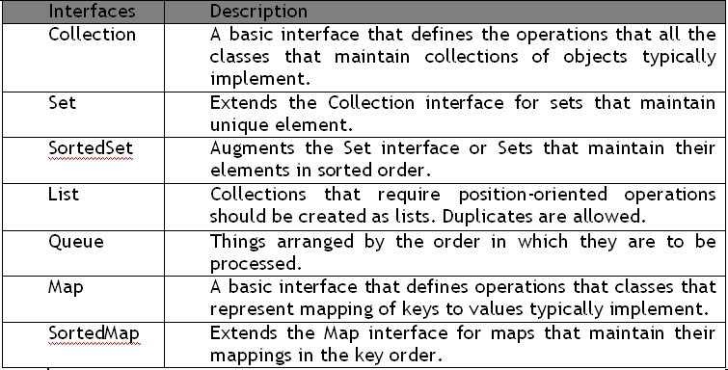

**ArrayList:**

ArrayList is a resizable array. It can grow and shrink dynamically as elements are added or removed.

ArrayList is Indexed: It maintains the insertion order and allows random access using an index (like an array).

**Some Important Methods:**

1.add(E e) Adds an element to the end of the list

2.add(int index, E element) Inserts element at the specified index

3.get(int index) Returns the element at the given index

4.remove(int index) Removed the element at the specified index

5.remove(Object o) Removes the first occurrence of the specified object

6.size() Returns the number of elements in the list

7.isEmpty() Checks if the list is empty

8.contains(Object o) Checks if the list contains the specified element

9.indexOf(Object o) Returns the index of the first occurrence of the specified element

10.lastIndexOf(Object o) Returns the index of the last occurrence of the specified element

**Example ArrayList of Strings:**

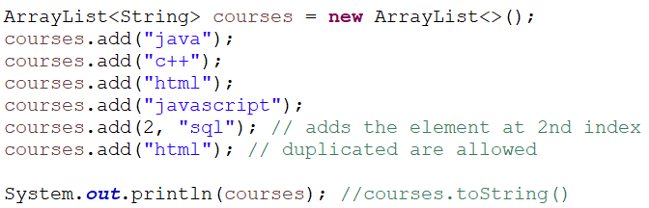

OUTPUT:



**Example ArrayList of Integers:**

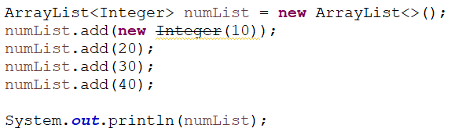

**Exmaple ArrayList methods:**

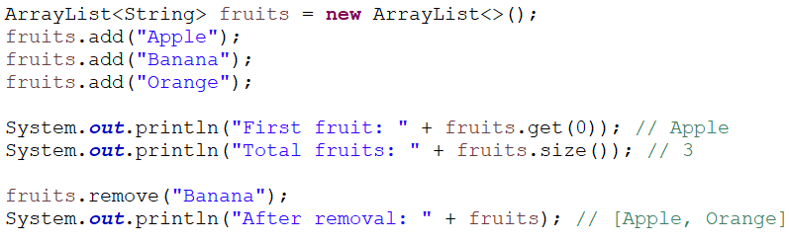

**Traversing Collections:**

1. Using enhanced for loop
2. Using Iterator interface
3. Using Java8 forEach loop

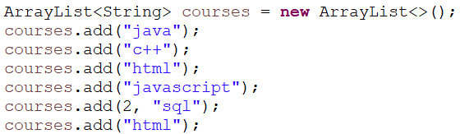

**Using enhanced for loop:**

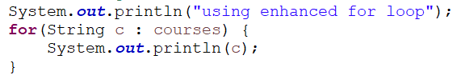

**Using Iterator interface**

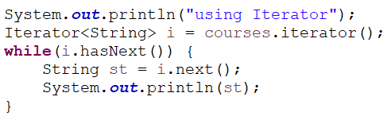

**Using Iterator interface**



**LinkedList:**

LinkedList is a **doubly-linked list** implementation of the List interfaces in Java.

Unlike ArrayList, which uses a dynamic array internally, LinkedList stores elements as **nodes**, where each node contains:

* the data (element)
* a reference to the **next** node
* a reference to the **previous** node

**Key Features of LinkedList**

Faster insertions and deletions (especially in the middle or beginning)

Slower random access (you must traverse from the head or tail)

Can be used as a stack, queue, or deque

**Methods in LinkedList:**

Same as ArrayList, plus some queue/deque-specific methods:

* addFirst(E e) – Adds element at the beginning
* addLast(E e) – Adds element at the end
* removeFirst() / removeLast() – Removes from beginning/end
* getFirst() / getLast() – Gets first/last element

**Example:**

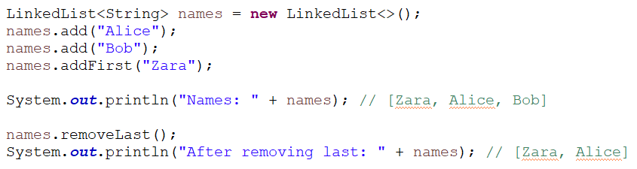

**List with Custom Objects:**

**Product.java:**

**public** **class** Product {

**private** **int** productId;

**private** String productName;

**private** **double** productPrice;

**private** String category;

//constructors

//setters and getters

}

**Main.java:**

public class Main {

public static void main(String[] args) {

Product p1 = new Product(10,” SonyHeadphone”,2000,”HeadPhone”);

Product p2 = new Product(20,”IPhone”,80000,”mobile”);

Product p3 = new Product(30,”DellXP”,12000,”laptop”);

ArrayList<Product> products = new ArrayList<>();

products.add(p1);

products.add(p2);

products.add(p3);

for(Product p: products) {

System.out.println(p.getProductId()+" "+p.getProductName()+" "+p.getProductPrice()+" "+p.getCategory());

}

}

}

**Sorting Collections:**

Use **Collection.sort(list)** method

This method sort the elements in ascending order by default.

Use **Collections.sort(list,Collections.reverseOrder())** to sort the Objects in Descending Order

**Example 1:**

ArrayList<String> fruits = **new** ArrayList<>();

fruits.add("Banana");

fruits.add("Apple");

fruits.add("Mango");

Collections.*sort*(fruits); // Sort alphabetically

System.***out***.println(fruits); // [Apple, Banana, Mango]

**Exmaple 2:**

ArrayList<Integer> numbers = **new** ArrayList<>();

numbers.add(30);

numbers.add(10);

numbers.add(20);

Collections.*sort*(numbers); // Sort in ascending order

System.***out***.println(numbers); // [10, 20, 30]

**Exmaple 3: Sort in Descending Order**

ArrayList<Integer> numbers = **new** ArrayList<>();

numbers.add(30);

numbers.add(10);

numbers.add(20);

Collections.*sort*(numbers, Collections.*reverseOrder*()); //sort in descending

System.***out***.println(numbers); // [30, 20, 10]

**Soring Custom Objects:**

Using Comparable and Comparator Interfaces we can sort the custom objects

**Comparable:**

Comparable is an interface **in java.lang package** that allows a class to define its **natural ordering** for sorting.

You implement this interface in your class and override the compareTo() method.

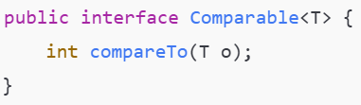

Returns:

* + 0 → this object equals o
  + Positive → this object is **greater** than o
  + Negative → this object is **less** than o

**Example:**

**Product.java**

public class Product implements Comparable<Product> {

private int productId;

private String productName;

private double productPrice;

private String category;

//constructors

//setters and getters

@Override

public int compareTo(Product p) {

// int result = this.productId - p.getProductId(); //sort products by its id in asc order

// int result = p.getProductId() - this.productId; //sort product by its id in desc order

int result = this.productName.compareTo(p.getProductName()); //sort by productName

return result;

}

**Main .java**

Product p1 = new Product(60,"IPhoneX",85000);

Product p2 = new Product(30,"SamsungF20",45000);

Product p3 = new Product(10,"SamsungM20",45000);

Product p4 = new Product(40,"IPhone15",95000);

ArrayList<Product> products = new ArrayList<>();

products.add(p1);

products.add(p2);

products.add(p3);

products.add(p4);

Collections.sort(products);

for(Product p: products) {

System.out.println(p.getProductId()+" "+p.getProductName()+" "+p.getProductPrice()); }

**Comparator:**

**Comparator** is an interface in the **java.util package** that lets you define custom sorting logic outside the class you want to sort.

It allows you to write **multiple sorting strategies** for the same object type.

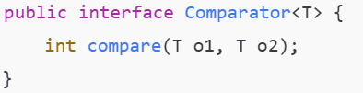

returns:

* 0 if o1 equals o2
* Positive if o1 > o2
* Negative if o1 < o2

To Sort the Object By using Comparator using Overloaded sort() method

**Collections.sort(list, <instanceOfCompartor>);**

**Example:**

**NameCompartor.java**

import java.util.*;

class NameComparator implements Comparator<Product> {

@Override

public int compare(Product p1,Product p2) {

return p1.getProductName().compareTo(p2.getProductName());

}

}

**NumberComparator.java**

import java.util.*;

class NumberComparator implements Comparator<Product> {

@Override

public int compare(Product p1,Product p2) {

return p1.getProductId()-p2.getProductId();

}

}

**Main.java**

Product p1 = new Product(60,"IPhoneX",85000);

Product p2 = new Product(30,"SamsungF20",45000);

Product p3 = new Product(10,"SamsungM20",45000);

Product p4 = new Product(40,"IPhone15",95000);

ArrayList<Product> products = new ArrayList<>();

products.add(p1);

products.add(p2);

products.add(p3);

products.add(p4);

System.out.println("Sort By Name:");

**NameComparator nameComp = new NameComparator();**

**Collections.sort(products,nameComp);**

for(Product p: products) {

System.out.println(p.getProductId()+" "+p.getProductName()+" "+p.getProductPrice());

}

System.out.println("Sort By Id:");

**NumberComparator numComp = new NumberComparator();**

**Collections.sort(products,numComp);**

for(Product p: products) {

System.out.println(p.getProductId()+" "+p.getProductName()+" "+p.getProductPrice());

}